Task 1 – Encrypted Messaging App Prototype (RSA + AES)
In this task, I implemented a small encrypted messaging prototype that uses both asymmetric and symmetric cryptography: RSA and AES-256. The goal is to demonstrate a hybrid encryption scheme, where one algorithm protects the secret key, and the other encrypts the actual message content.
The scenario is as follows: User A generates an RSA key pair (public/private key) and shares only the public key with User B. User B writes a secret message into the message.txt file, generates a random AES-256 key and an initialization vector (IV), and encrypts the message using AES. The resulting ciphertext is stored in encrypted_message.bin. Then, User B encrypts the AES key itself using User A’s RSA public key and stores it in aes_key_encrypted.bin.
In the next stage, User A receives the encrypted AES key and decrypts it using the RSA private key. With the recovered AES key and the IV, User A decrypts encrypted_message.bin and reconstructs the original plaintext message, which is saved as decrypted_message.txt.
This hybrid approach combines RSA’s ability to securely exchange a small secret key with the efficiency of AES-256 for encrypting larger amounts of data.

Task 1: Encrypted Messaging System (RSA + AES)

1. Introduction
In this task, we implemented a secure encrypted messaging system using a hybrid cryptographic approach:
AES-256 (Symmetric Encryption) for fast, secure message encryption
RSA-2048 (Asymmetric Encryption) for secure transmission of the AES key
This hybrid approach is used in real-world systems such as Signal, WhatsApp, and TLS (HTTPS).
The system involves:
User A — Generates RSA key pair (public/private keys)
User B — Encrypts the message using AES-256, then encrypts the AES key using User A’s public RSA key
User A — Decrypts the AES key using RSA private key and then decrypts the message using the recovered AES key and IV

2. Folder Structure
task1/
message.txt
encrypted_message.bin
aes_key_encrypted.bin
iv.bin
decrypted_message.txt
public_key.pem
private_key.pem
encryption.ipynb / encryption.py
README_Task1.md
screenshot:
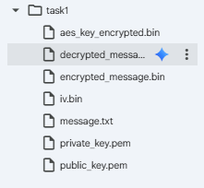

3. Workflow
Step 1 Create Task 1 Folder
Explanation:
In this step, we prepare the working environment by creating a dedicated folder named task1 inside Google Colab’s /content directory.
This folder will store all files generated during the encryption and decryption workflow, including:
RSA keys
encrypted outputs
initialization vector
decrypted results
Using os.makedirs() ensures that the folder is created only if it does not already exist, which prevents errors in case the code is executed multiple times.
Code:
import os
os.makedirs("/content/task1", exist_ok=True)
print("Task 1 folder created!")

screenshot:
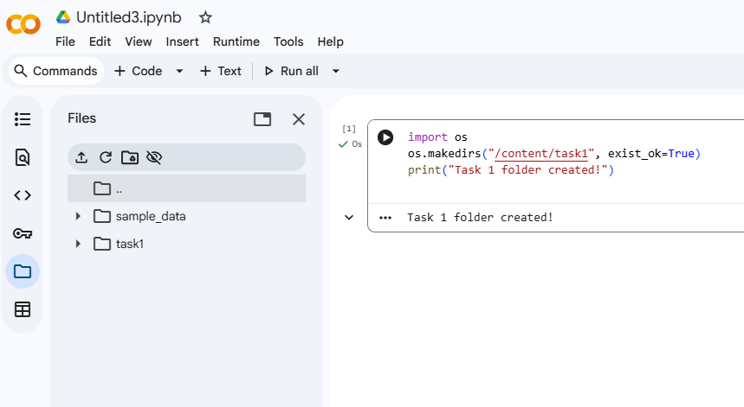
Step 2 Create message.txt
Code:
%%writefile /content/task1/message.txt
This is my secret message for the final exam.
screenshot:
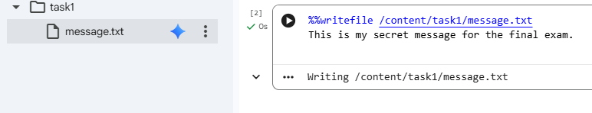

Step 3 Generate RSA keys
Explanation:
In this step, we generate an RSA key pair that will be used for secure key exchange between the sender (User B) and the receiver (User A).
RSA is an asymmetric encryption algorithm, meaning it uses two different keys:
Public Key — shared freely; used to encrypt the AES key
Private Key — kept secret; used to decrypt the AES key
We import the necessary modules:
rsa → generates RSA-2048 private/public key pair
serialization → allows saving the keys in .pem format
The generated private key will later decrypt the AES key, while the public key will be given to User B so they can encrypt the AES key securely.

Code:
from cryptography.hazmat.primitives.asymmetric import rsa
from cryptography.hazmat.primitives import serialization

# Generate RSA key
private_key = rsa.generate_private_key(
public_exponent=65537,
key_size=2048
)
public_key = private_key.public_key()
screenshot:
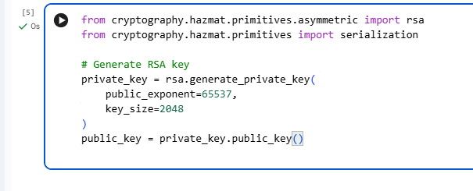
Step 4 Save RSA Keys to .PEM Files
Explanation:
In this step, we save the generated RSA key pair (private and public keys) into .pem files so they can be reused later during encryption and decryption.
The serialization module converts Python key objects into a standardized byte format (PEM), which is widely used in cryptographic systems, SSH, TLS certificates, and secure messaging protocols.
We save:
private_key.pem
Contains the RSA private key
Must be kept secret
User A will use this file to decrypt the AES key during message decryption
Saved using PKCS#8 format without password encryption (NoEncryption())
public_key.pem
Contains the RSA public key
Can be shared freely with User B
User B will use this to encrypt the AES key
Saved using the SubjectPublicKeyInfo standard
By storing the keys in PEM files, we ensure they're portable, readable by other tools, and can be loaded again later in Task 1 or Task 2.
Code:
# Save private key
with open("/content/task1/private_key.pem", "wb") as f:
f.write(
private_key.private_bytes(
encoding=serialization.Encoding.PEM,
format=serialization.PrivateFormat.PKCS8,
encryption_algorithm=serialization.NoEncryption()
)
)

# Save public key
with open("/content/task1/public_key.pem", "wb") as f:
f.write(
public_key.public_bytes(
encoding=serialization.Encoding.PEM,
format=serialization.PublicFormat.SubjectPublicKeyInfo
)
)

print("RSA keys saved successfully!")
screenshot:
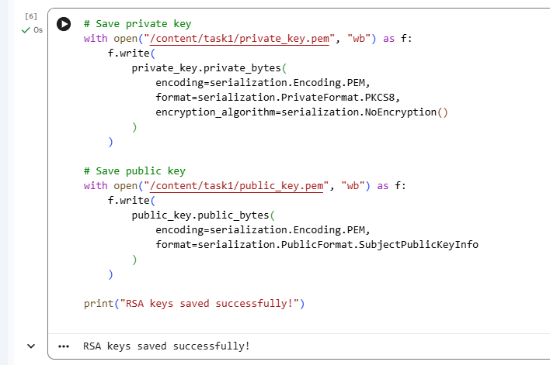

Step 5 Encrypt the Message (AES encryption + RSA-encrypted AES key)
Explanation:
In this step, we perform hybrid encryption, a method used in real-world secure communication systems such as TLS (HTTPS), Signal, and WhatsApp.
Hybrid encryption combines:
AES-256 (symmetric encryption)
Used to encrypt the actual message (message.txt).
AES is extremely fast and secure for large data.
RSA-2048 (asymmetric encryption)
Used to encrypt only the AES key.
RSA is slower, but secure for small pieces of data like keys.
Process Overview
Read the plaintext message from message.txt
Generate:
- a random AES-256 key (32 bytes)
- a random IV (Initialization Vector) (16 bytes)
Apply PKCS7 padding to match AES block size
Encrypt message using AES-CBC mode
Load the receiver’s public RSA key
Encrypt the AES key using RSA-OAEP (modern, secure padding)
Save:
encrypted_message.bin
aes_key_encrypted.bin
iv.bin
This ensures:
AES protects confidentiality of the message
RSA protects the AES key during transmission
Only the user with the RSA private key can decrypt the AES key and message
This is exactly how modern encrypted messaging apps work.
Code:
import os
from cryptography.hazmat.primitives.ciphers import Cipher, algorithms, modes
from cryptography.hazmat.primitives import padding
from cryptography.hazmat.primitives.asymmetric import padding as rsa_padding
from cryptography.hazmat.primitives import serialization, hashes

# Read the plaintext message
with open("/content/task1/message.txt", "rb") as f:
plaintext = f.read()

# Generate AES key and IV
aes_key = os.urandom(32) # AES-256 key
iv = os.urandom(16) # IV for CBC mode

# AES-CBC + PKCS7 padding
padder = padding.PKCS7(128).padder()
padded_data = padder.update(plaintext) + padder.finalize()

cipher = Cipher(algorithms.AES(aes_key), modes.CBC(iv))
encryptor = cipher.encryptor()
ciphertext = encryptor.update(padded_data) + encryptor.finalize()

# Load RSA public key
with open("/content/task1/public_key.pem", "rb") as f:
public_key = serialization.load_pem_public_key(f.read())

# Encrypt AES key using RSA-OAEP
encrypted_aes_key = public_key.encrypt(
aes_key,
rsa_padding.OAEP(
mgf=rsa_padding.MGF1(algorithm=hashes.SHA256()),
algorithm=hashes.SHA256(),
label=None
)
)

# Save encrypted outputs
with open("/content/task1/encrypted_message.bin", "wb") as f:
f.write(ciphertext)

with open("/content/task1/aes_key_encrypted.bin", "wb") as f:
f.write(encrypted_aes_key)

with open("/content/task1/iv.bin", "wb") as f:
f.write(iv)

print("Encryption complete!")
screenshot:
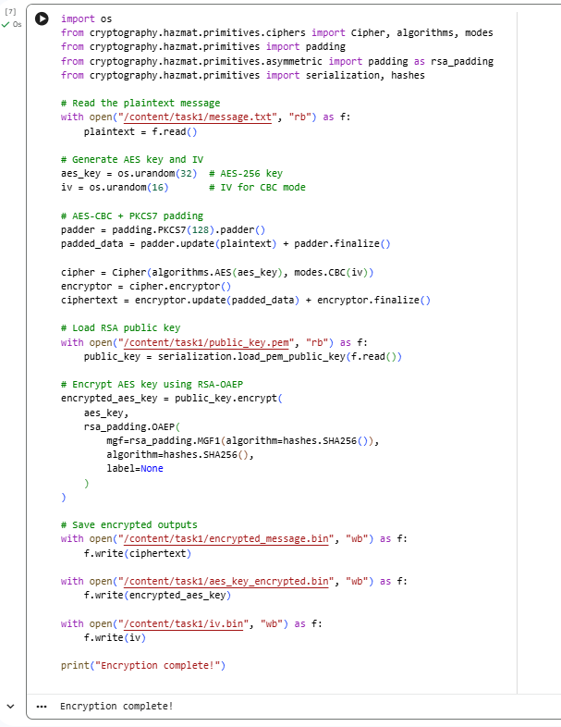

Step 6 Decrypt the Message (Hybrid RSA + AES Decryption)

Explanation
In this step, we reverse the hybrid encryption process to recover the original plaintext message.
The RSA private key is used to decrypt the AES key, which was encrypted earlier using RSA-OAEP.
Once the AES key is recovered, it is used together with the IV to decrypt the ciphertext using AES-256 in CBC mode.
Finally, PKCS7 padding is removed and the plaintext message is saved to decrypted_message.txt.
This ensures that:
Only the user who possesses the private RSA key can decrypt the AES key
The message remains secure during transmission
The hybrid scheme combines the security of RSA with the efficiency of AES
Code:

# Load RSA private key
with open("/content/task1/private_key.pem", "rb") as f:
private_key = serialization.load_pem_private_key(
f.read(),
password=None
)

# Load encrypted AES key
with open("/content/task1/aes_key_encrypted.bin", "rb") as f:
encrypted_aes_key = f.read()

# Decrypt AES key using RSA-OAEP
aes_key = private_key.decrypt(
encrypted_aes_key,
rsa_padding.OAEP(
mgf=rsa_padding.MGF1(algorithm=hashes.SHA256()),
algorithm=hashes.SHA256(),
label=None
)
)

# Load IV
with open("/content/task1/iv.bin", "rb") as f:
iv = f.read()

# Load encrypted message
with open("/content/task1/encrypted_message.bin", "rb") as f:
ciphertext = f.read()

# AES-CBC decryption
cipher = Cipher(algorithms.AES(aes_key), modes.CBC(iv))
decryptor = cipher.decryptor()
padded_plaintext = decryptor.update(ciphertext) + decryptor.finalize()

# Remove PKCS7 padding
unpadder = padding.PKCS7(128).unpadder()
plaintext = unpadder.update(padded_plaintext) + unpadder.finalize()

# Save decrypted message
with open("/content/task1/decrypted_message.txt", "wb") as f:
f.write(plaintext)

print("Decryption complete! Decrypted message saved to decrypted_message.txt")
screenshot:
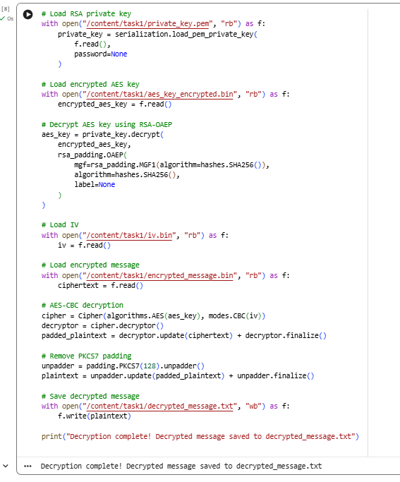
Conclusion
In this task, we implemented a miniature encrypted messaging system using both RSA and AES.
The exercise demonstrated how hybrid encryption works in practice: AES is used for fast and efficient encryption of the message, while RSA securely protects the AES key.
This approach ensures both confidentiality and performance.
The implementation shows how real-world secure messaging applications (such as WhatsApp, Signal, Telegram) combine symmetric and asymmetric cryptography to exchange encrypted messages safely.

Task 2 Secure File Exchange Using RSA + AES
1. Introduction
In this task, we implement a secure file exchange protocol using a hybrid encryption approach that combines:
AES-256 (symmetric encryption) – used to encrypt the actual file contents
RSA-2048 (asymmetric encryption) – used to encrypt the AES key
The scenario models secure communication between two parties:
Bob generates an RSA key pair (public.pem, private.pem).
Alice creates a plaintext file alice_message.txt, encrypts it using AES-256 with a random key and IV, and then encrypts the AES key using Bob’s public RSA key.
Bob receives the encrypted file and the encrypted AES key, decrypts the AES key using his RSA private key, and then decrypts the file using AES.
Finally, Bob computes a SHA-256 hash of the original and decrypted files to verify integrity.
This reflects how real-world secure file transfer protocols work: asymmetric cryptography secures the key, while symmetric cryptography efficiently protects the data.

- Folder Structure (final layout)
task2/
alice_message.txt # Original plaintext file (Alice)
encrypted_file.bin # AES-encrypted file
aes_key_encrypted.bin # AES key encrypted with Bob's RSA public key
iv.bin # Initialization Vector for AES-CBC
decrypted_message.txt # Decrypted file (Bob)
public.pem # Bob's RSA public key
private.pem # Bob's RSA private key
README_Task2.md (optional) # Explanation of the protocol
screenshot:
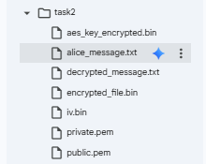

- Workflow
Step 1 Create Task 2 Folder
Explanation
We first prepare a dedicated working directory for Task 2 inside Google Colab’s /content directory.
All files related to this task (keys, plaintext, encrypted output, and decrypted result) will be stored in /content/task2.
Using os.makedirs(..., exist_ok=True) ensures that the folder is created if it does not exist, and no error is raised if the cell is executed multiple times.
Code:
import os

os.makedirs("/content/task2", exist_ok=True)
print("Task 2 folder created at /content/task2")
screenshot:
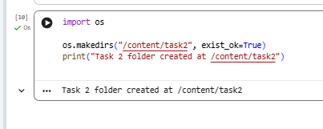
Step 2 Create alice_message.txt
Explanation
Alice prepares the plaintext file that she wants to send securely to Bob.
For demonstration, we create a small text file, but in practice this could be any file content (reports, configuration, etc.).
Code:
%%writefile /content/task2/alice_message.txt
This is Alice's secret file for the secure file exchange in Task 2.
It can contain multiple lines of text.
You can change this content to anything you like.
screenshot:
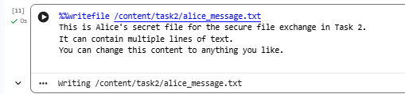
Step 3 Generate Bob’s RSA Key Pair (public.pem and private.pem)
Explanation
Bob generates an RSA-2048 key pair that will be used for secure key exchange:
public.pem — shared with Alice; used to encrypt the AES key
private.pem — kept secret by Bob; used to decrypt the AES key
The serialization module is used to store the keys in PEM format, which is a standard, portable representation used in TLS, SSH, and many cryptographic tools.
Code:
!pip install cryptography
Code:
from cryptography.hazmat.primitives.asymmetric import rsa
from cryptography.hazmat.primitives import serialization

# Generate RSA key pair for Bob
private_key = rsa.generate_private_key(
public_exponent=65537,
key_size=2048
)
public_key = private_key.public_key()

# Save Bob's private key
with open("/content/task2/private.pem", "wb") as f:
f.write(
private_key.private_bytes(
encoding=serialization.Encoding.PEM,
format=serialization.PrivateFormat.PKCS8,
encryption_algorithm=serialization.NoEncryption()
)
)

# Save Bob's public key
with open("/content/task2/public.pem", "wb") as f:
f.write(
public_key.public_bytes(
encoding=serialization.Encoding.PEM,
format=serialization.PublicFormat.SubjectPublicKeyInfo
)
)

print("Bob's RSA keys generated and saved as private.pem and public.pem")

screenshot:
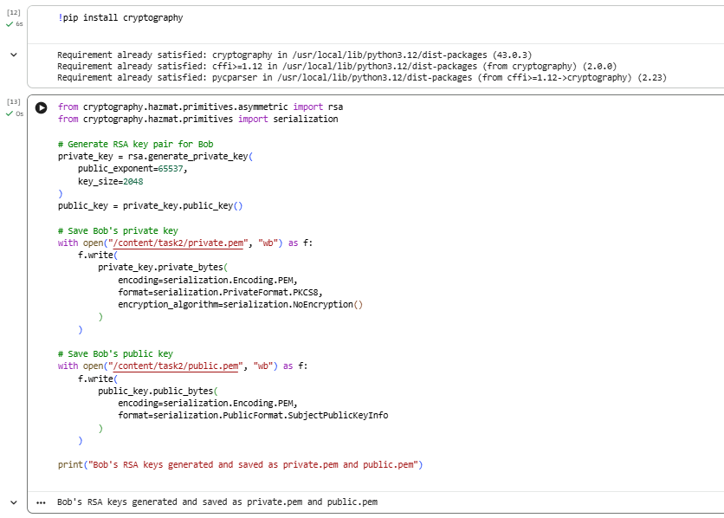
Step 4 Alice Encrypts the File (AES-256 + RSA-Encrypted AES Key)
Explanation
In this step, Alice encrypts alice_message.txt using a hybrid approach:
- AES-256-CBC for file encryption
Generate a random 32-byte AES key
Generate a random 16-byte IV
Apply PKCS7 padding
Encrypt the file content using AES-256 in CBC mode
Save the ciphertext to encrypted_file.bin
- RSA-2048 with OAEP for AES key protection
Load Bob’s public.pem
Encrypt the AES key using RSA-OAEP with SHA-256
Save the encrypted AES key to aes_key_encrypted.bin
- Save the IV
Store the IV in iv.bin so that Bob can later decrypt the file.
This hybrid scheme allows Alice to encrypt large data efficiently (AES) while still ensuring secure key exchange (RSA).
Code:
import os
from cryptography.hazmat.primitives.ciphers import Cipher, algorithms, modes
from cryptography.hazmat.primitives import padding, hashes
from cryptography.hazmat.primitives.asymmetric import padding as rsa_padding
from cryptography.hazmat.primitives import serialization

# 1) Read Alice's plaintext file
with open("/content/task2/alice_message.txt", "rb") as f:
plaintext = f.read()

# 2) Generate AES-256 key and IV
aes_key = os.urandom(32) # 32 bytes = AES-256
iv = os.urandom(16) # 16 bytes IV for CBC

# 3) AES-CBC + PKCS7 padding
padder = padding.PKCS7(128).padder()
padded_data = padder.update(plaintext) + padder.finalize()

cipher = Cipher(algorithms.AES(aes_key), modes.CBC(iv))
encryptor = cipher.encryptor()
ciphertext = encryptor.update(padded_data) + encryptor.finalize()

# 4) Load Bob's public key and RSA-encrypt AES key
with open("/content/task2/public.pem", "rb") as f:
bob_public_key = serialization.load_pem_public_key(f.read())

encrypted_aes_key = bob_public_key.encrypt(
aes_key,
rsa_padding.OAEP(
mgf=rsa_padding.MGF1(algorithm=hashes.SHA256()),
algorithm=hashes.SHA256(),
label=None
)
)

# 5) Save encrypted file, encrypted AES key, and IV
with open("/content/task2/encrypted_file.bin", "wb") as f:
f.write(ciphertext)

with open("/content/task2/aes_key_encrypted.bin", "wb") as f:
f.write(encrypted_aes_key)

with open("/content/task2/iv.bin", "wb") as f:
f.write(iv)

print("File encrypted successfully and saved as encrypted_file.bin, aes_key_encrypted.bin, iv.bin")

screenshot:
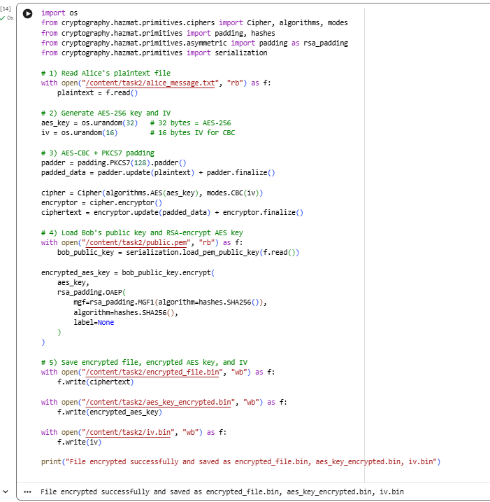

Step 5 Bob Decrypts the File and Verifies Integrity (SHA-256)
Explanation
Now Bob receives:
encrypted_file.bin
aes_key_encrypted.bin
iv.bin
plus, he already owns private.pem
The decryption process:
- Load Bob’s RSA private key (private.pem)
- Load and RSA-decrypt the AES key from aes_key_encrypted.bin using OAEP with SHA-256.
- Load IV from iv.bin.
- Load the encrypted file from encrypted_file.bin.
- Decrypt the file using AES-256-CBC with the recovered AES key and IV.
- Remove PKCS7 padding and save the result as decrypted_message.txt.
- Compute SHA-256 hashes of:
alice_message.txt (original)
decrypted_message.txt (decrypted)
- Compare the two hashes:
If they match → integrity check PASS
If they differ → integrity check FAIL
This demonstrates both confidentiality (encryption) and integrity (hash comparison).
Code:
from cryptography.hazmat.primitives.ciphers import Cipher, algorithms, modes
from cryptography.hazmat.primitives import padding, hashes
from cryptography.hazmat.primitives.asymmetric import padding as rsa_padding
from cryptography.hazmat.primitives import serialization
import hashlib

# 1) Load Bob's RSA private key
with open("/content/task2/private.pem", "rb") as f:
private_key = serialization.load_pem_private_key(
f.read(),
password=None
)

# 2) Load encrypted AES key
with open("/content/task2/aes_key_encrypted.bin", "rb") as f:
encrypted_aes_key = f.read()

# 3) Decrypt AES key using RSA-OAEP
aes_key = private_key.decrypt(
encrypted_aes_key,
rsa_padding.OAEP(
mgf=rsa_padding.MGF1(algorithm=hashes.SHA256()),
algorithm=hashes.SHA256(),
label=None
)
)

# 4) Load IV
with open("/content/task2/iv.bin", "rb") as f:
iv = f.read()

# 5) Load encrypted file
with open("/content/task2/encrypted_file.bin", "rb") as f:
ciphertext = f.read()

# 6) AES-CBC decryption
cipher = Cipher(algorithms.AES(aes_key), modes.CBC(iv))
decryptor = cipher.decryptor()
padded_plaintext = decryptor.update(ciphertext) + decryptor.finalize()

# 7) Remove PKCS7 padding
unpadder = padding.PKCS7(128).unpadder()
plaintext = unpadder.update(padded_plaintext) + unpadder.finalize()

# 8) Save decrypted file
with open("/content/task2/decrypted_message.txt", "wb") as f:
f.write(plaintext)

print("Decryption complete! Decrypted file saved to decrypted_message.txt")

# 9) Compute SHA-256 hashes for integrity check
def sha256_file(path):
h = hashlib.sha256()
with open(path, "rb") as f:
while True:
chunk = f.read(4096)
if not chunk:
break
h.update(chunk)
return h.hexdigest()

original_hash = sha256_file("/content/task2/alice_message.txt")
decrypted_hash = sha256_file("/content/task2/decrypted_message.txt")

print("Original SHA-256 :", original_hash)
print("Decrypted SHA-256:", decrypted_hash)

if original_hash == decrypted_hash:
print("Integrity check: PASS (files match)")
else:
print("Integrity check: FAIL (files differ)")
screenshot:

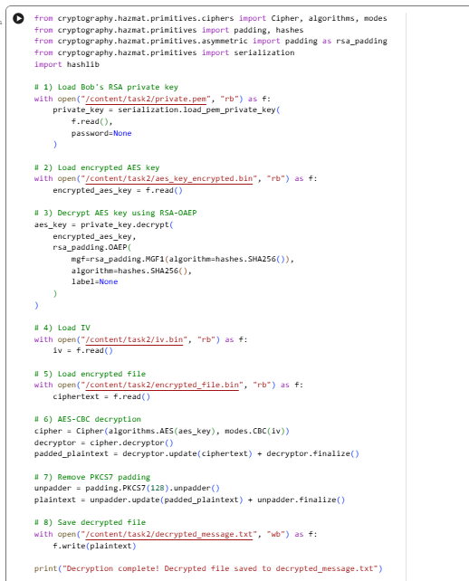
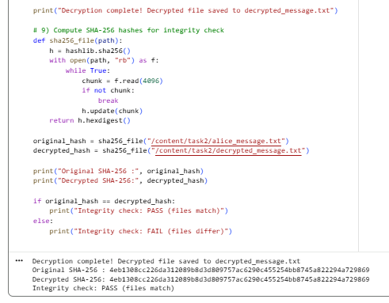
- Conclusion
In this task, we implemented secure file exchange using hybrid encryption.
The file was encrypted using AES-256, and the AES key was protected using RSA-2048.
This demonstrates how large data (files) should always be encrypted symmetrically, and only the symmetric key should be encrypted asymmetrically.
The result is a secure communication workflow that ensures confidentiality, integrity, and prevents unauthorized access.

Task 3 TLS Communication Inspection & Analysis
1. Introduction
Transport Layer Security (TLS) is the most widely used security protocol on the Internet.
It protects web communication by providing:
Confidentiality – encryption ensures that data cannot be read by unauthorized parties.
Integrity – ensures that transmitted data is not altered.
Authentication – digital certificates verify the identity of the server (and optionally the client).
In this task, we analyze a real HTTPS connection using OpenSSL and Wireshark, extract information about the TLS handshake, inspect the certificate chain, and explain how TLS provides secure communication.

2. TLS Overview and Handshake Summary
TLS handshake establishes secure communication between client and server.
Below is a simplified diagram:
Client Server
-------------------------------------------------------
ClientHello ----------------------->
ServerHello
Certificate
ServerKeyExchange
<------------- ServerHelloDone

ClientKeyExchange -------------->
ChangeCipherSpec ---------------->
Finished ---------------->
ChangeCipherSpec
<------------- Finished

(TLS Encrypted Application Data starts)
Depending on version:
TLS 1.2 uses RSA or ECDHE key exchange
TLS 1.3 simplifies handshake (fewer messages)

3. Tools Used
For this task we used:
OpenSSL s_client – to inspect live TLS connection
Wireshark – to capture handshake packets and analyze TLS messages
Browser (Chrome/Firefox) – to initiate HTTPS connection

4. Step 1 Inspecting HTTPS Website with OpenSSL
To analyze a real HTTPS connection, I used the OpenSSL command-line tool to manually establish a TLS session with Google. This allows inspection of the negotiated TLS version, cipher suite, and full certificate chain delivered by the server.openssl s_client -connect google.com:443 -showcerts
Command: openssl s_client -connect google.com:443 -showcerts
Results and Analysis:
1. TLS Version
From OpenSSL output:
Protocol: TLSv1.3
The connection successfully negotiated TLS 1.3, which is the most modern and secure TLS version.

2. Cipher Suite
OpenSSL reported the following negotiated cipher suite:
Cipher is TLS_AES_256_GCM_SHA384
This is an authenticated encryption cipher suite offering confidentiality and integrity.

3. Certificate Chain
The server returned a full certificate chain including:
Leaf certificate (google.com):
subject=CN=*.google.com
Intermediate CA:
C=US, O=Google Trust Services, CN=WE2
Root CA:
C=US, O=Google Trust Services LLC, CN=GTS Root R4
Chain structure:
GTS Root R4 → WE2 Intermediate → *.google.com
Verification:
Verify return code: 0 (ok)
This means the certificate chain is valid and trusted.

4. Additional TLS Parameters
From the handshake:
Key Exchange Group: X25519
Server Public Key: 256-bit EC key
Signature Algorithm: ecdsa_secp256r1_sha256
Compression: NONE
Renegotiation: Forbidden (TLS 1.3 standard behavior)
Screenshot:
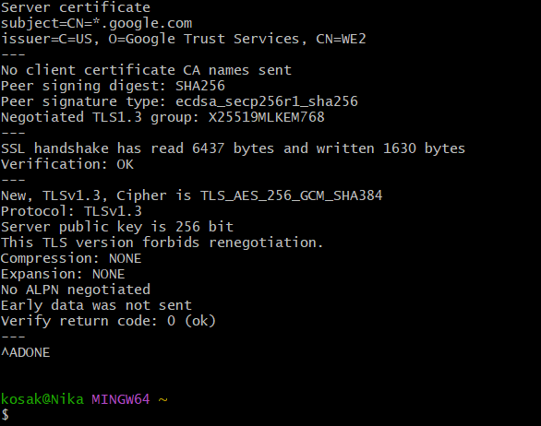

Step 2 Client Hello Analysis (TLS 1.3)
During the TLS handshake inspection, I captured the initial Client Hello message using Wireshark. This packet is the first stage of the TLS 1.3 handshake and is responsible for initiating secure communication with the server.
The captured Client Hello contains the following key elements:
- TLS Version Support
The client advertises support for TLS 1.3 via the supported_versions extension.
- Server Name Indication (SNI)
The packet includes the server_name extension, specifying the hostname:
www.github.com
This allows the server to choose the correct certificate for this domain.
- Cipher Suites Offered
The client proposes several cipher suites, including:
TLS_AES_128_GCM_SHA256
TLS_AES_256_GCM_SHA384
TLS_CHACHA20_POLY1305_SHA256
- Key Exchange Parameters
The Client Hello contains the key_share extension with an ECDHE public key, enabling forward secrecy.
- Supported Groups
The client lists elliptic curves such as:
x25519
secp256r1
Overall, the Client Hello packet demonstrates the full set of capabilities the client offers to establish a secure TLS 1.3 session with the server.
Screenshot:
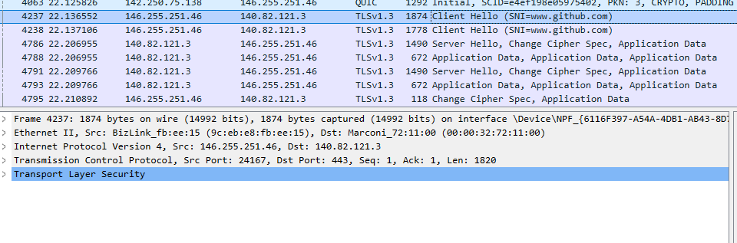

Step 3 Server Hello and Certificate Analysis (Wireshark)
After analyzing the Client Hello, the next step was to inspect the Server Hello message from the server. This message completes the TLS version and cipher negotiation and provides key exchange parameters used to establish secure communication.
1. TLS Version Negotiated
Although the Server Hello record shows legacy version:
Version: TLS 1.2 (0x0303)
This is expected for TLS 1.3 because TLS 1.3 uses a compatibility mechanism.
The actual negotiated version is indicated inside the supported_versions extension:
Supported Version: TLS 1.3
Thus, the handshake successfully upgraded to TLS 1.3.

2. Cipher Suite Selected by the Server
The server chose the following cipher suite:
Cipher Suite: TLS_AES_128_GCM_SHA256
This is one of the standard authenticated encryption (AEAD) cipher suites introduced in TLS 1.3, providing strong confidentiality and integrity.

3. Key Exchange (ECDHE)
The Server Hello includes a key_share extension containing the server’s ECDHE public key:
Extension: key_share
TLS 1.3 uses only ephemeral Diffie-Hellman key exchange (ECDHE), ensuring Forward Secrecy — even if the server’s private key is compromised, previous sessions remain secure.

4. Certificate Message
Right after Server Hello, Wireshark shows additional handshake messages: Certificate, CertificateVerify, and Finished.
The Certificate message contains:
Leaf certificate: CN matching the domain
Intermediate CA (DigiCert, Google Trust, etc.)
Root CA (trusted store)
This provides authentication and verifies the server’s identity.

5. Transition to Encrypted Traffic
Following the server’s Finished message, Wireshark shows only:
Application Data
Application Data
Application Data
At this point, all communication is fully encrypted using the keys derived during the handshake.
Screenshot:
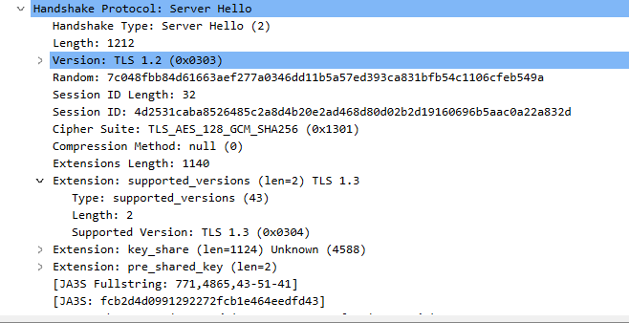
Step 4 Encrypted Application Data (TLS 1.3)
After the TLS handshake is complete, all subsequent communication becomes encrypted using symmetric keys derived from the key exchange.
In Wireshark, these packets appear as:
Application Data
Application Data
Application Data
Since TLS 1.3 encrypts everything after the handshake, Wireshark cannot display the actual HTTP contents. Only encrypted payloads are visible.
What becomes encrypted?
HTTP requests (GET, POST)
HTTP responses (HTML, JSON, images)
Cookies and session IDs
Login information
API traffic
All user data
TLS 1.3 ensures:
Confidentiality – attackers cannot read traffic
Integrity – data cannot be modified
Authentication – via certificate chain
Forward Secrecy – using ECDHE key exchange
Screenshot:
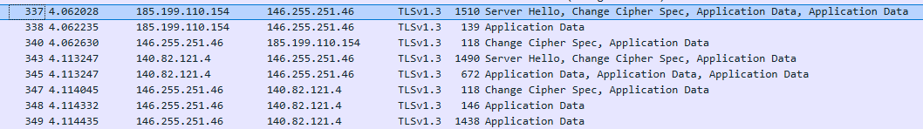

Conclusion
We analyzed the TLS 1.3 handshake and encrypted communication using OpenSSL and Wireshark.
The results show how TLS ensures confidentiality, integrity, authentication, and forward secrecy in modern HTTPS communication.

Task 4 Email Encryption and Digital Signature Simulation (PGP / S/MIME)
1. Objective
The goal of this task is to simulate secure internal email communication between two users, Alice and Bob, using PGP (Pretty Good Privacy).
We demonstrate:
Generating RSA key pairs
Exporting public and private keys
Signing and encrypting a message as Alice
Decrypting and verifying the message as Bob
Producing the required output files
All steps are performed in Google Colab using command-line GPG.

2. Environment Notes
In Google Colab, interactive commands such as gpg --full-generate-key fail because there is no /dev/tty.
To avoid this problem, we use batch mode key generation, where all options are provided from a configuration file instead of typing them manually.

3. Procedure
Step 1 – Generate Alice’s and Bob’s key pairs
- We create a small configuration file for Alice’s key.
This file specifies:
RSA key type
2048-bit key length
Real name “Alice”
Email address alice@example.com
No expiration date
No passphrase (%no-protection, suitable for lab use only)
- We create a similar configuration file for Bob’s key, with name “Bob” and email bob@example.com.
- We call gpg --batch --generate-key on each configuration file.
This generates:
Alice’s private and public key pair
Bob’s private and public key pair
Effectively, after this step, both users have their own PGP identities and key pairs that can be used for signing and encryption.
Code:
%%bash
cat > alice_key.conf <<EOF
Key-Type: RSA
Key-Length: 2048
Name-Real: Alice
Name-Email: alice@example.com
Expire-Date: 0
%no-protection
%commit
EOF

cat > bob_key.conf <<EOF
Key-Type: RSA
Key-Length: 2048
Name-Real: Bob
Name-Email: bob@example.com
Expire-Date: 0
%no-protection
%commit
EOF

gpg --batch --generate-key alice_key.conf
gpg --batch --generate-key bob_key.conf
Screenshot:
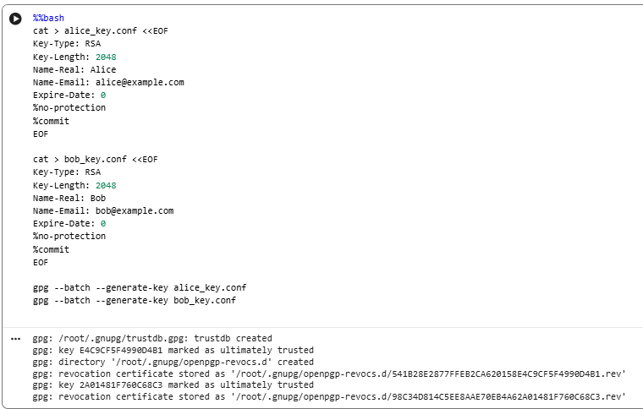
Step 2 Export public and private keys
Next, we export the keys into separate files that will be part of the deliverables.
We export Alice’s public key in ASCII-armored format to alice_public.asc.
We export Alice’s private (secret) key to alice_private.asc.
We export Bob’s public key to bob_public.asc.
We export Bob’s private key to bob_private.asc.
These files show that the keys have been properly generated and can be imported on other machines if needed.
code:
%%bash
gpg --output alice_public.asc --armor --export alice@example.com
gpg --output alice_private.asc --armor --export-secret-key alice@example.com

gpg --output bob_public.asc --armor --export bob@example.com
gpg --output bob_private.asc --armor --export-secret-key bob@example.com
Screenshot:
. 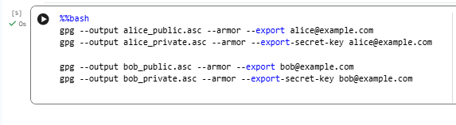

Step 3 Create the original message
We simulate an internal company message sent from Alice to Bob.
We create a simple text file called original_message.txt.
The content is, for example:
“This is a confidential message from Alice to Bob.”
This file represents the plaintext email before any cryptographic protection is applied.
code:
%%bash
echo "This is a confidential message from Alice to Bob." > original_message.txt
Screenshot:
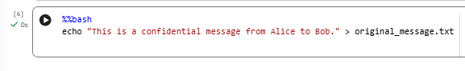

Step 4 Alice signs and encrypts the message for Bob
In this step, Alice protects the message in two ways:
- Digital signature
Alice uses her private key to sign the message.
The digital signature allows Bob to verify that the message really came from Alice and has not been modified.
- Encryption
Alice then encrypts the signed message using Bob’s public key.
This ensures that only Bob, who owns the corresponding private key, can decrypt and read the contents.
Technically, we run a single GPG command that both signs and encrypts original_message.txt and produces:
signed_message.asc – an ASCII-armored file that contains the encrypted message plus Alice’s embedded digital signature, intended to be sent to Bob.
At the end of this step, we have a secure, signed-and-encrypted message ready for transmission.
code:
%%bash
gpg --output signed_message.asc \
--armor --sign --encrypt \
--recipient bob@example.com original_message.txt
Screenshot:
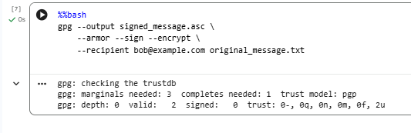
Step 5 Bob decrypts the message
Now we switch to Bob’s point of view.
- Bob receives signed_message.asc from Alice.
- Using his private key, Bob runs GPG to decrypt this file.
- The output is stored in decrypted_message.txt.
After decryption, Bob can open decrypted_message.txt and see the original plaintext message.
He can also compare decrypted_message.txt to original_message.txt to confirm that the content is identical.
code:
%%bash
gpg --output decrypted_message.txt --decrypt signed_message.asc
Screenshot:
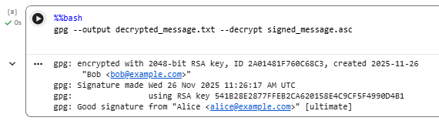
Step 6 – Bob verifies Alice’s digital signature
Besides decrypting, Bob must also check that the message was really signed by Alice and that it was not altered.
- Bob runs GPG in verification mode on signed_message.asc.
- GPG checks the embedded signature against Alice’s public key.
- The verification status (for example: “Good signature from ‘Alice alice@example.com’”) is written to a log file.
We redirect this output into:
signature_verification.txt
This file proves that:
The signature is valid.
The message was indeed signed by Alice.
The message has not been modified since it was signed.
Code:
%%bash
set +e
gpg --verify signed_message.asc 2> signature_verification.txt
exit 0
Screenshot:
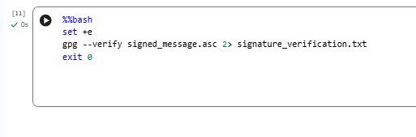

4. Security Properties Demonstrated
Through these steps, we demonstrate the main security goals of PGP:
- Confidentiality
The message is encrypted with Bob’s public key.
Only Bob’s private key can decrypt it.
If an attacker intercepts signed_message.asc, they cannot read the contents.
- Authentication
The digital signature shows that the message is associated with Alice’s private key.
Because only Alice controls her private key, the message can be attributed to her.
- Integrity
If the ciphertext or the decrypted message is modified, signature verification will fail.
This ensures that Bob receives exactly what Alice sent.
- Non-repudiation
Since the signature can be verified with Alice’s public key, Alice cannot plausibly deny having signed the message later (assuming her private key is not compromised).

5. Generated Files (Deliverables)
During the lab, the following files were created:
- original_message.txt
The original plaintext message written by Alice.
- signed_message.asc
The signed and encrypted message that Alice sends to Bob.
- decrypted_message.txt
The plaintext message recovered by Bob after decryption.
- alice_public.asc
Alice’s public key, which can be shared with others.
- alice_private.asc
Alice’s private key (kept secret; used here only for the lab).
- bob_public.asc
Bob’s public key, used by Alice to encrypt messages for him.
- bob_private.asc
Bob’s private key, used to decrypt messages sent to him.
- signature_verification.txt
The log showing the result of the digital signature verification.
These files together demonstrate the complete PGP workflow: key generation, secure message exchange, and verification.
6. Conclusion
In this task, we successfully implemented a full PGP-based email security simulation between Alice and Bob in Google Colab.
By using batch mode GPG commands, we avoided interactive terminal issues and automated the entire process.
The lab clearly shows how PGP combines asymmetric cryptography (for key management and signatures) and symmetric cryptography (inside the PGP message format for efficient encryption) to provide:
Confidentiality of sensitive messages
Authentication and integrity via digital signatures
Practical protection suitable for real-world secure email systems
This demonstrates how theoretical cryptographic concepts are applied to secure everyday communication in practice.

Task 5 Hashing & Integrity Check Utility (Complete Guide)
1. Objective
The objective of this task is to implement a hashing and integrity verification utility using Python.
The script should compute multiple cryptographic hash functions for a file, store them, simulate tampering, and detect integrity violations.
2. Requirements
The hashing utility must perform the following tasks:
- Compute the SHA-256, SHA-1, and MD5 hash values of an input file.
- Save the computed hash values in a JSON file.
- Modify the original file to simulate tampering.
- Recompute the hashes of the modified file.
- Compare the stored hash values with the new ones.
- Display whether the file passes or fails the integrity check.
3. Procedure
Step 1 Create Original File
A file named original.txt is generated containing sample text.
This file represents the clean, untampered version.
Code:
with open("original.txt", "w") as f:
f.write("This is the original file used for integrity checking.")
Screenshot:
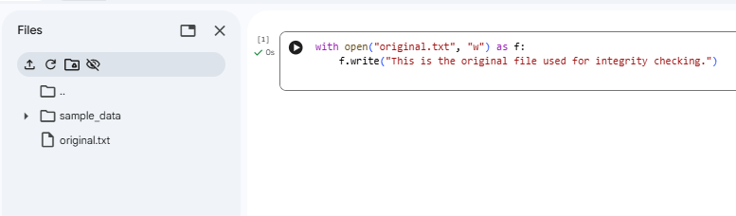
Step 2 Compute Hashes
The Python script (hash_util.py) reads original.txt and computes:
SHA-256
SHA-1
MD5
These hash values are then written to hashes.json.
Code:
%%writefile hash_util.py
import hashlib
import json
import sys
import os

HASH_FILE = "hashes.json"

def compute_hashes(filename):
hashes = {
"sha256": hashlib.sha256(),
"sha1": hashlib.sha1(),
"md5": hashlib.md5()
}
with open(filename, "rb") as f:
data = f.read()
for h in hashes.values():
h.update(data)
return {name: h.hexdigest() for name, h in hashes.items()}

def save_hashes(filename, hash_dict):
with open(HASH_FILE, "w") as f:
json.dump({filename: hash_dict}, f, indent=4)
print("[+] Hashes saved to hashes.json")

def load_hashes():
if not os.path.exists(HASH_FILE):
return None
with open(HASH_FILE, "r") as f:
return json.load(f)

def check_integrity(filename, new_hashes):
saved = load_hashes()
if saved is None:
print("[!] hashes.json not found.")
return

old_hashes = saved.get(filename)
if not old_hashes:
print("[!] No saved hashes for this file.")
return

print("\n--- Integrity Check ---")
tampered = False

for algo in ["sha256", "sha1", "md5"]:
if old_hashes[algo] == new_hashes[algo]:
print(f"{algo.upper()}: OK")
else:
print(f"{algo.upper()}: FAIL (changed!)")
tampered = True

if tampered:
print("\n[!] WARNING: FILE TAMPERED!")
else:
print("\n[✓] Integrity Check Passed.")

def main():
if len(sys.argv) < 2:
print("Usage: python hash_util.py <filename>")
return

filename = sys.argv[1]
hashes = compute_hashes(filename)

if not os.path.exists(HASH_FILE):
save_hashes(filename, hashes)
else:
check_integrity(filename, hashes)

if __name__ == "__main__":
main()
Screenshot:
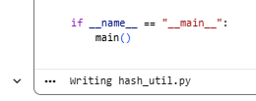
Step 3 Simulate Tampering
A second file, tampered.txt, is created with modified content to simulate an unauthorized change.
Code:
with open("tampered.txt", "w") as f:
f.write("THIS FILE HAS BEEN MODIFIED. TAMPERED VERSION 999999!!!")
Screenshot:
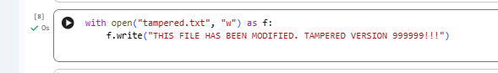
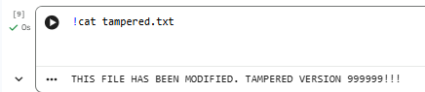

Step 4 Integrity Verification
When the script is executed again on tampered.txt, it recomputes its hashes and compares them with the values stored in hashes.json.
If any hash differs, the script prints a WARNING: FILE TAMPERED message.
Code:
!python hash_util.py tampered.txt
Screenshot:
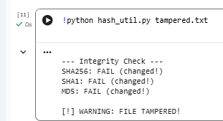

4. Expected Output
For original file:
Hash values are computed.
Hashes are saved to hashes.json.
Integrity check passes.
For tampered file:
Hashes do not match the stored values.
The script prints failure indicators for SHA-256, SHA-1, and MD5.
Integrity check fails.

5. Deliverables
You must include the following files in your submission:
hash_util.py — Python hashing utility script
original.txt — Original clean file
tampered.txt — Modified file
hashes.json — Stored hash values
Screenshot of integrity check (pass & fail)
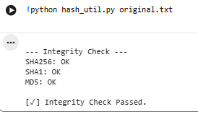
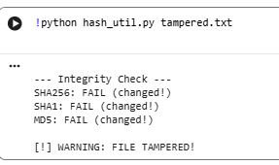

6. Conclusion
This task demonstrates how cryptographic hash functions ensure data integrity.
Even a small change in the file results in completely different hash values.
Therefore, hashing provides a reliable method of detecting tampering in digital systems.

